**Lab 6 – SEQUENCE DIAGRAM**

**Submission:** Each group needs to submit sequence diagrams for each use case.

***Step by step to create a sequence diagram.***

1. Identify a set of objects that will participate in the general collaboration (or use case scenario)
   1. If you derive the sequence diagram based on a scenario of a use case, select the normal scenarios first
   2. You should know the primary actor(s) who activates the use case
2. Consider the first point of the scenario (or if you get it from the first point of the flow of event of a use case)
3. Consider what the system need to be done in order to respond to the actor, when the actor send the message to the system
   1. What needs to be handled before the return message response back from the system?
   2. E.g. A customer inserted an ATM card into the machine, the system would display "input pin number" in the normal scenario, right?
   3. Guess, what will be handled inside by a set of objects at the "back" of the system? Something like, read and verify the ATM card (card reader), read the card information of the card holder (by the bank) and ask for the pin, or, return "invalid card type, insert another card", and etc.
   4. By this way, you will identify the candidate objects and operations of the target application for that particular scenario and you can also use this information as a basis to derive the class diagram incrementally.
4. Repeat each of the points of the scenario (or flow of event) and until you complete all the points in the scenario.

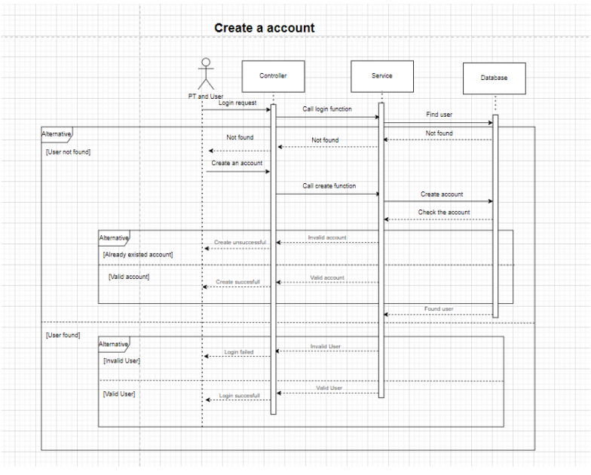

**Create an account scenario** with PT and User as actors. The first point of the scenario is when the PT or User sends the Login request to the system.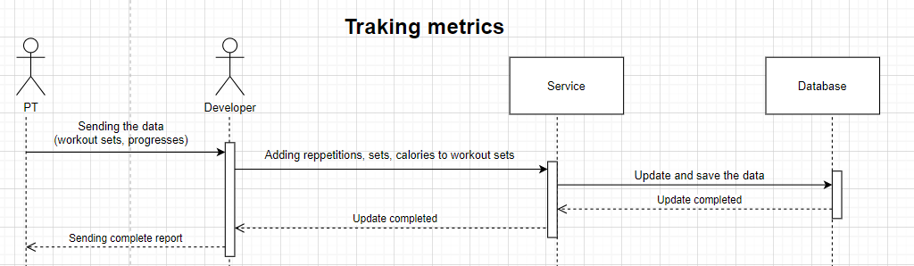

**Tracking metrics scenario** with PT and Developer as actors. The first point of the scenario is when the PT sends the data of workout sets, progresses, etc. to the Developer.

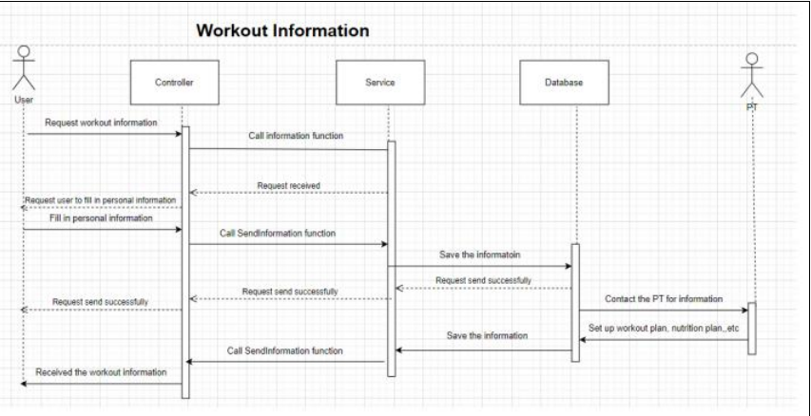

**Workout Information scenario** with User and PT as actors. The first point of the scenario is when the User sends the request workout information to the system.

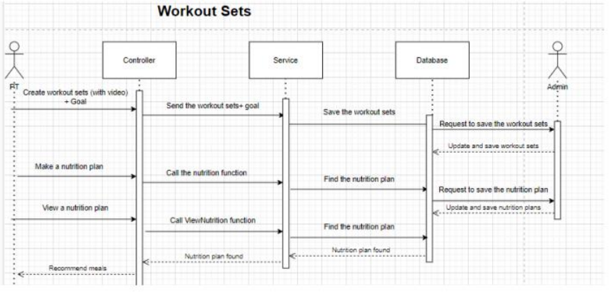

**Workout Sets scenario** with Admin and PT as actors. The first point of the scenario is when the PT creates workout sets with the video and the goal of the users.

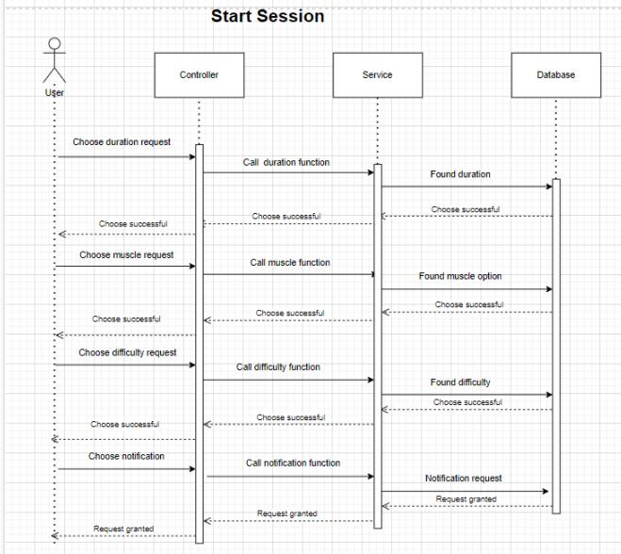

**Start Session scenario** with User as actors. The first point of the scenario is when the User chooses a duration request and sends it to the system.

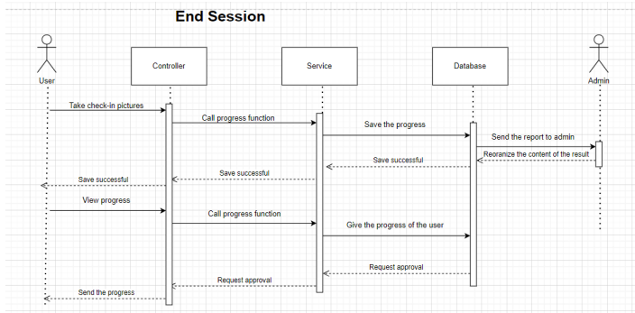

**End session** with User and Admin as actors. Starts with User taking a picture to check-in on that day, then User can view their updated progress.

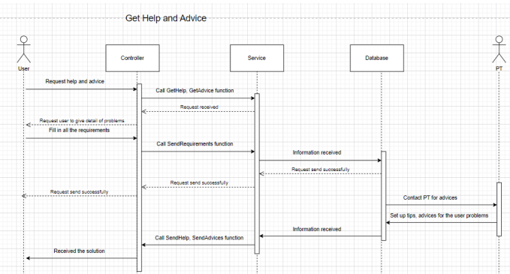

**Get help and advice** with User and PT as actors. Starts with User requesting help and advice by filling the form, then the form is sent by the system to the PT and back to the customer with the response.

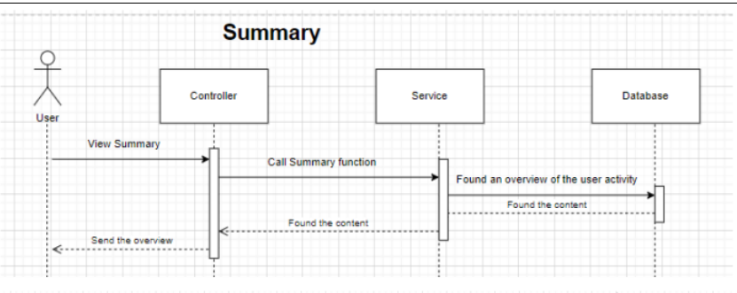

**Summary** with User as actor. Starts with User press the summary button, then the system will find and send it to the User.

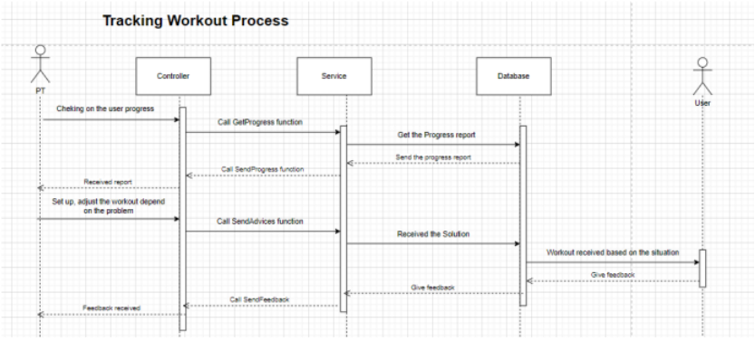

**Tracking workout progress** with User and PT as actors. Starts with PT checking the user's progress and adjusting if necessary, then the adjustment will be sent to the User. Lastly, User will send feedback on the adjustment to the PT.